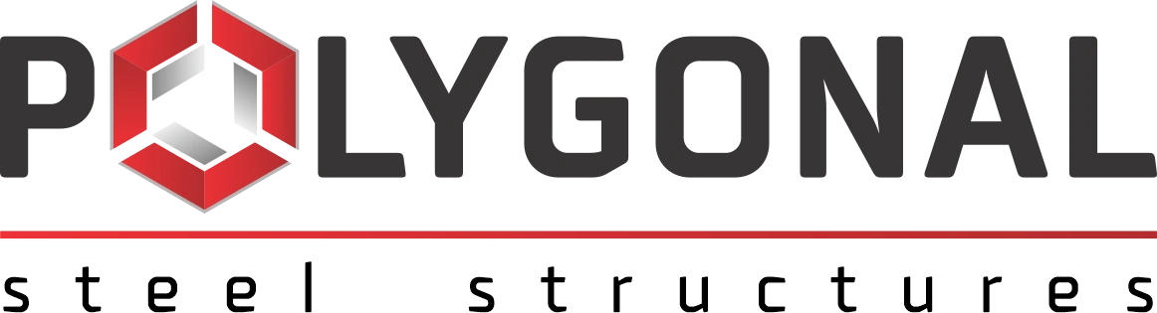 Polygonal Steel Structures · polygonal.com.ua · +38 (050) 685-93-45 · info@polygonal.com.ua
QUESTIONNAIRE
for a hot-dip galvanising line
(to be completed by the customer for preparing a commercial offer)

Please fill in the fields below in as much detail as possible. Unfilled items will be taken at their default values (see the italic notes), which may lead to an inaccurate calculation or the need to request the data again.
1. Customer data
Customer organisation | full name
Organisation address
Country
Contact person | full name, position
Phone / e-mail
Place of installation | country, region, city

2. Customer's activity
Mark your choice with a cross (several options are possible).
The company's activity: ☐ hot-dip galvanising ☐ electrolytic zinc plating ☐ structural steel fabrication ☐ engineering ☐ other (please specify)
3. What is required
Mark your choice with a cross (several options are possible).
Installation: ☐ general hot-dip galvanising (new plant) ☐ general hot-dip galvanising (revamping of an existing plant) ☐ automatic pipe galvanising ☐ automatic wire galvanising ☐ galvanising of small parts (fasteners)
Separate equipment: ☐ galvanising furnace ☐ heat recovery equipment ☐ drying oven ☐ degreasing and pickling line ☐ white fume extraction and filters ☐ equipment for lifting and handling hanger beams (traverses) ☐ centrifuge for small parts ☐ spent acid regeneration plant ☐ ancillary equipment (please specify) ☐ other (please specify)
4. Production data
Annual galvanising volume, t | minimum
Working hours per day
Working days per year

Standards required for the coating: ☐ ISO 1461 (DSTU EN ISO 1461) ☐ other (please specify)
5. For general galvanising
To be completed for a general galvanising plant only.
Light items (thickness under 3 mm), %
Medium items (thickness 3 to 6 mm), %
Heavy items (thickness over 6 mm), %
Maximum item length, mm
Maximum item width, mm
Maximum item height, mm

6. For automatic pipe galvanising
To be completed for automatic pipe galvanising only.
Pipe length, minimum, mm
Pipe length, maximum, mm
Outer diameter, minimum, mm
Outer diameter, maximum, mm
Wall thickness, minimum, mm
Wall thickness, maximum, mm

7. Building and lifting equipment
Is a building (shed) available? ☐ yes (please enclose a layout or sketch) ☐ no
Building length, m
Building width, m
Number of bays
Height of the crane runways, m
Available area (if there is no building), m²

Are overhead cranes available? ☐ yes ☐ no
Number of hoists
Hoist capacity, kg
Number of overhead cranes

8. Utilities
Available fuel: ☐ natural gas ☐ liquefied gas (LPG)
Lower heating value of natural gas, kcal/Nm³
Lower heating value of LPG, kcal/Nm³
Voltage (3-phase), V | typically 380
Frequency, Hz | typically 50
Available power, kW

9. Site conditions
Data for the industrial site where the line will be located.
Altitude above sea level, m
Maximum outside temperature, °C
Minimum outside temperature, °C
Groundwater level below ground level, m

10. Regulatory requirements
Are EU emission limits applied in the customer's country? ☐ yes ☐ no (please enclose the limits that apply)
Is CE-marked machinery allowed in the customer's country? ☐ yes ☐ no
11. Notes

Please send us the completed questionnaire: we will prepare a commercial offer from it. If some data is not available yet, leave the field blank and we will clarify it separately.
Completed by (full name, position): ____________________________ | Date: ____________________________
Signature: ____________________________
Please send the completed form to info@polygonal.com.ua

